1. User Story - Tests Generator
• Add a button option to generate a feature file for user stories.
• The frontend should include a “Generate Feature File” button.
• The backend should use the corresponding system prompt.
• Display the generated feature file in the UI.
2. User Story Tests Generator - Jira Integration
• Implement Jira integration using vibe coding to fetch user stories in both frontend and backend.
• Integrate with Jira to fetch stories.
• Introduce a “Fetch User Stories” button to retrieve stories.

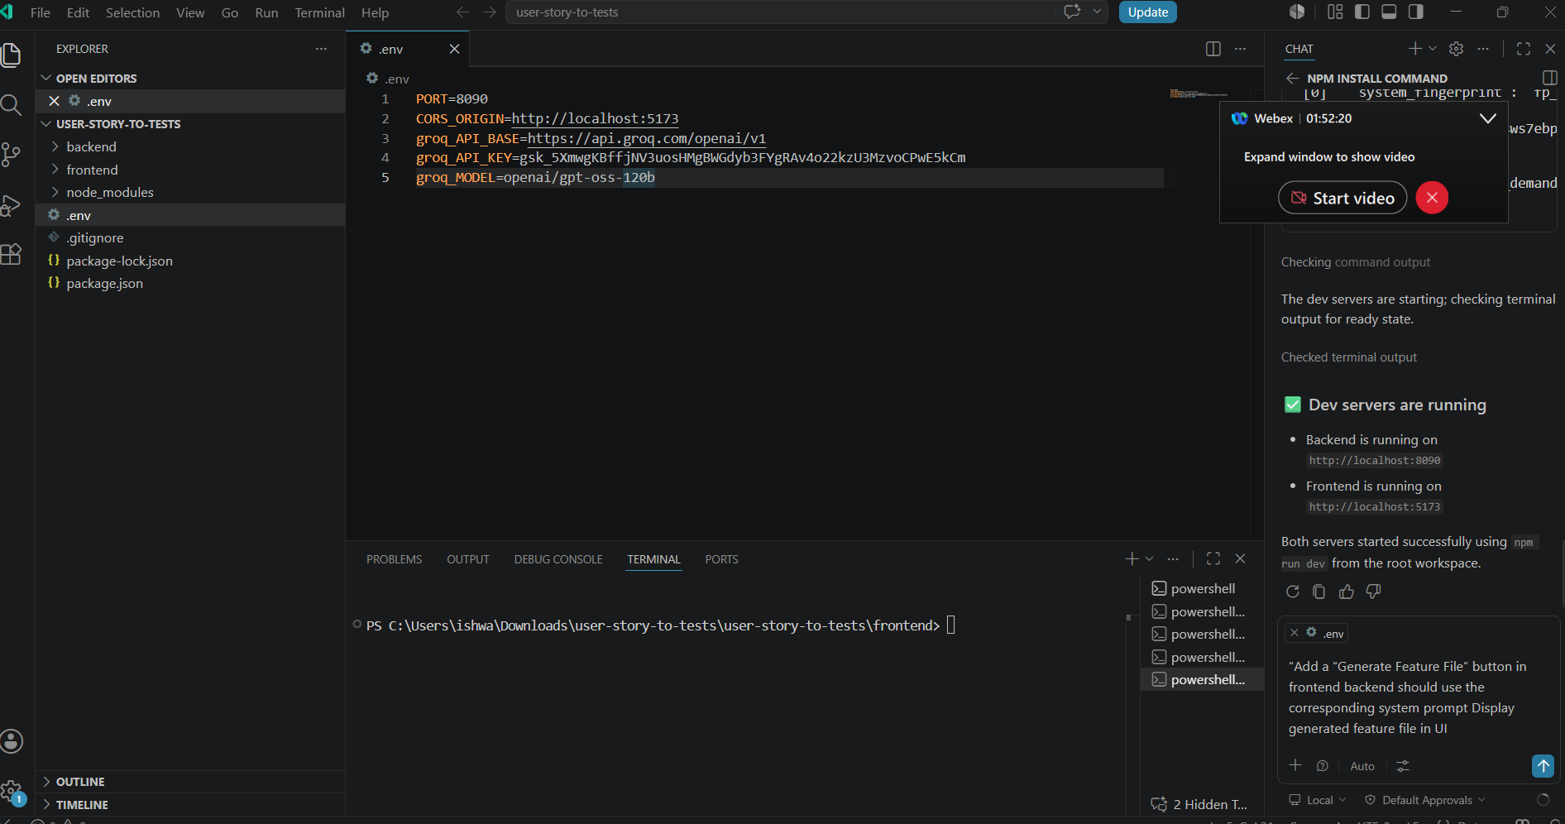

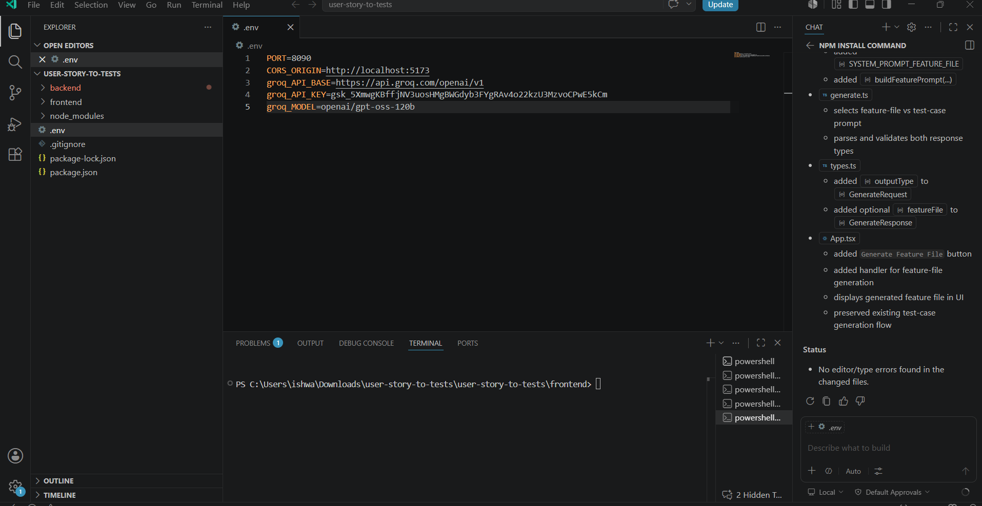

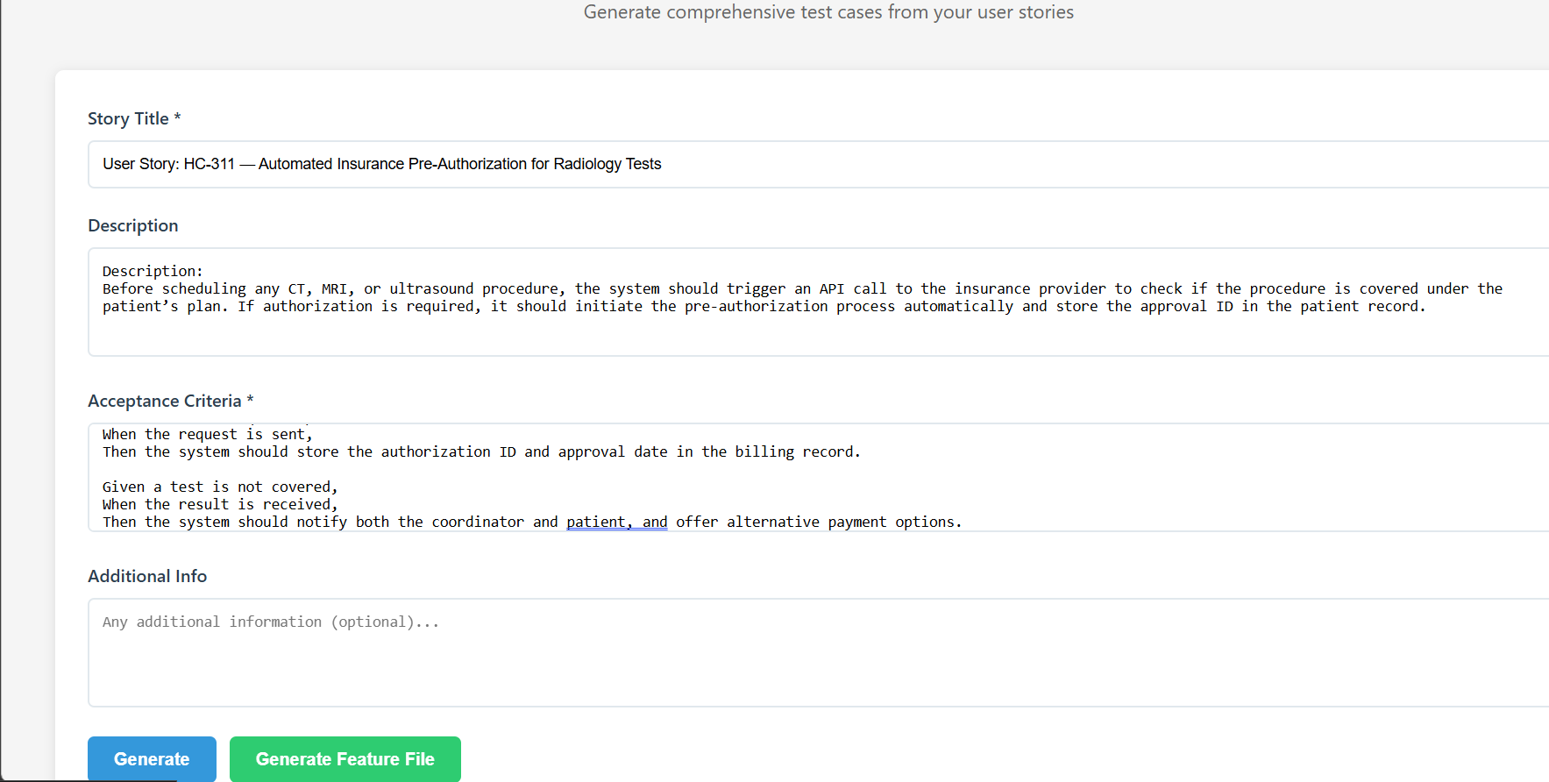

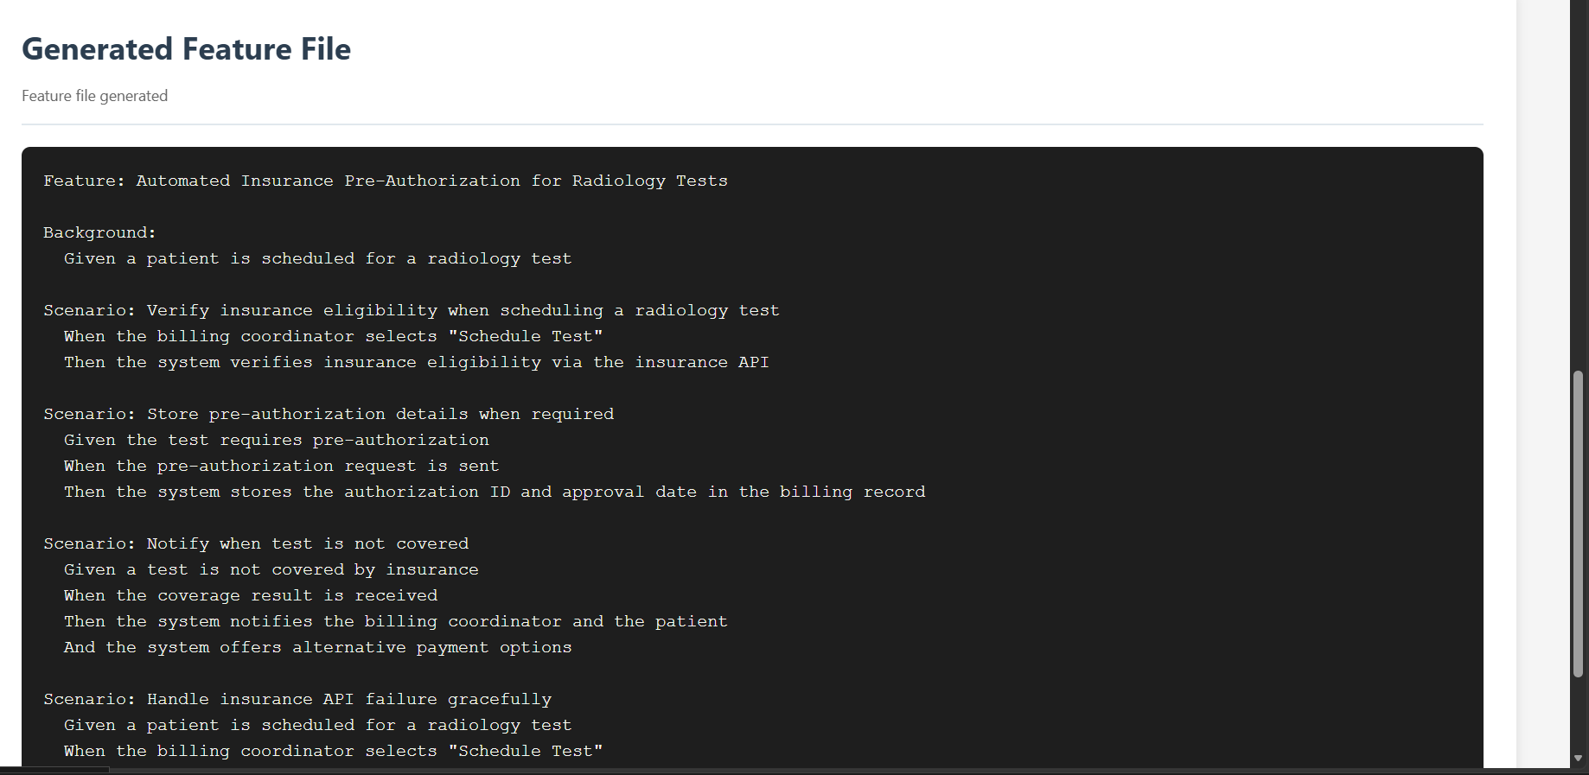

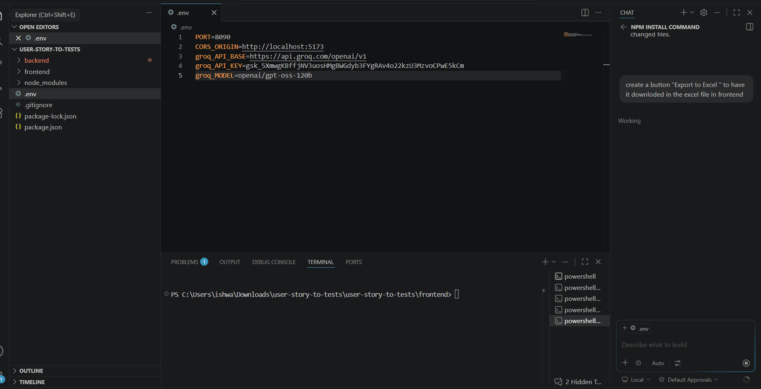

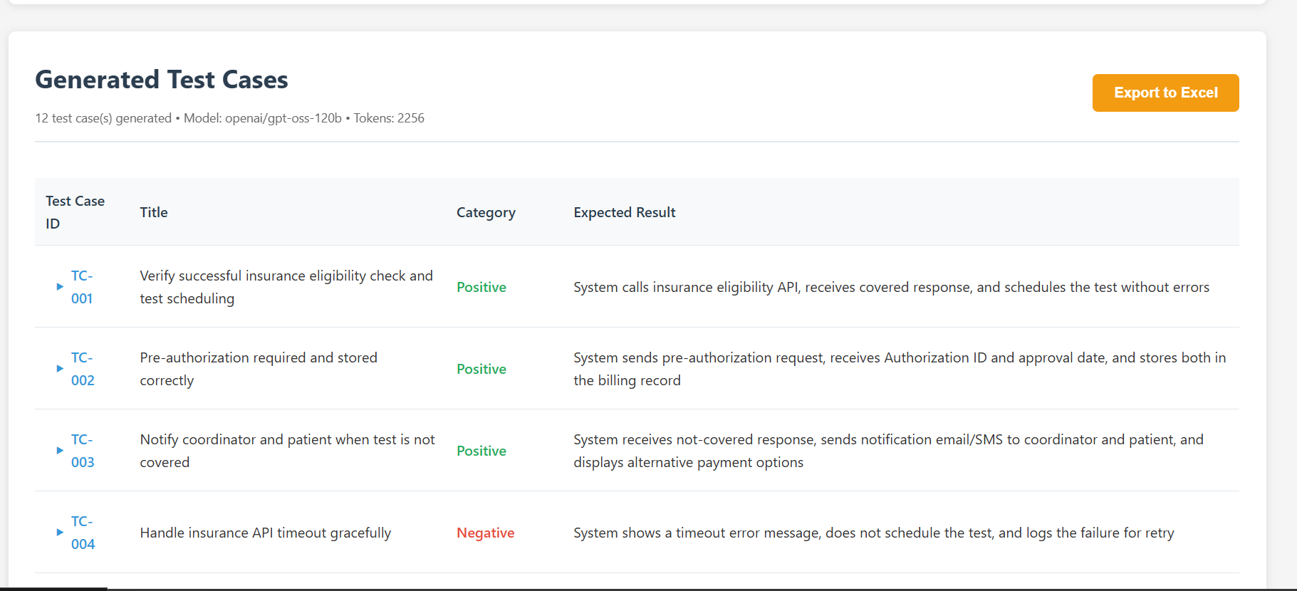

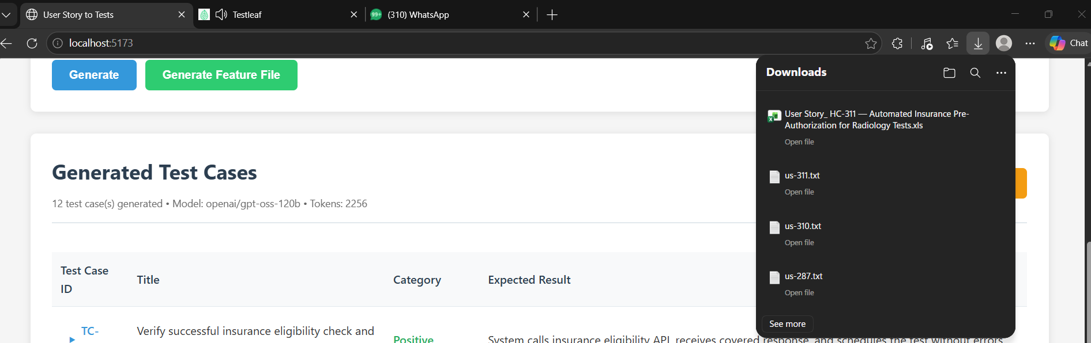

2.User story tests generator – with Vibe coding implement the Jira integration to fetch the user stories(both front end and backend)

Integration with JIRA to fetch the stories
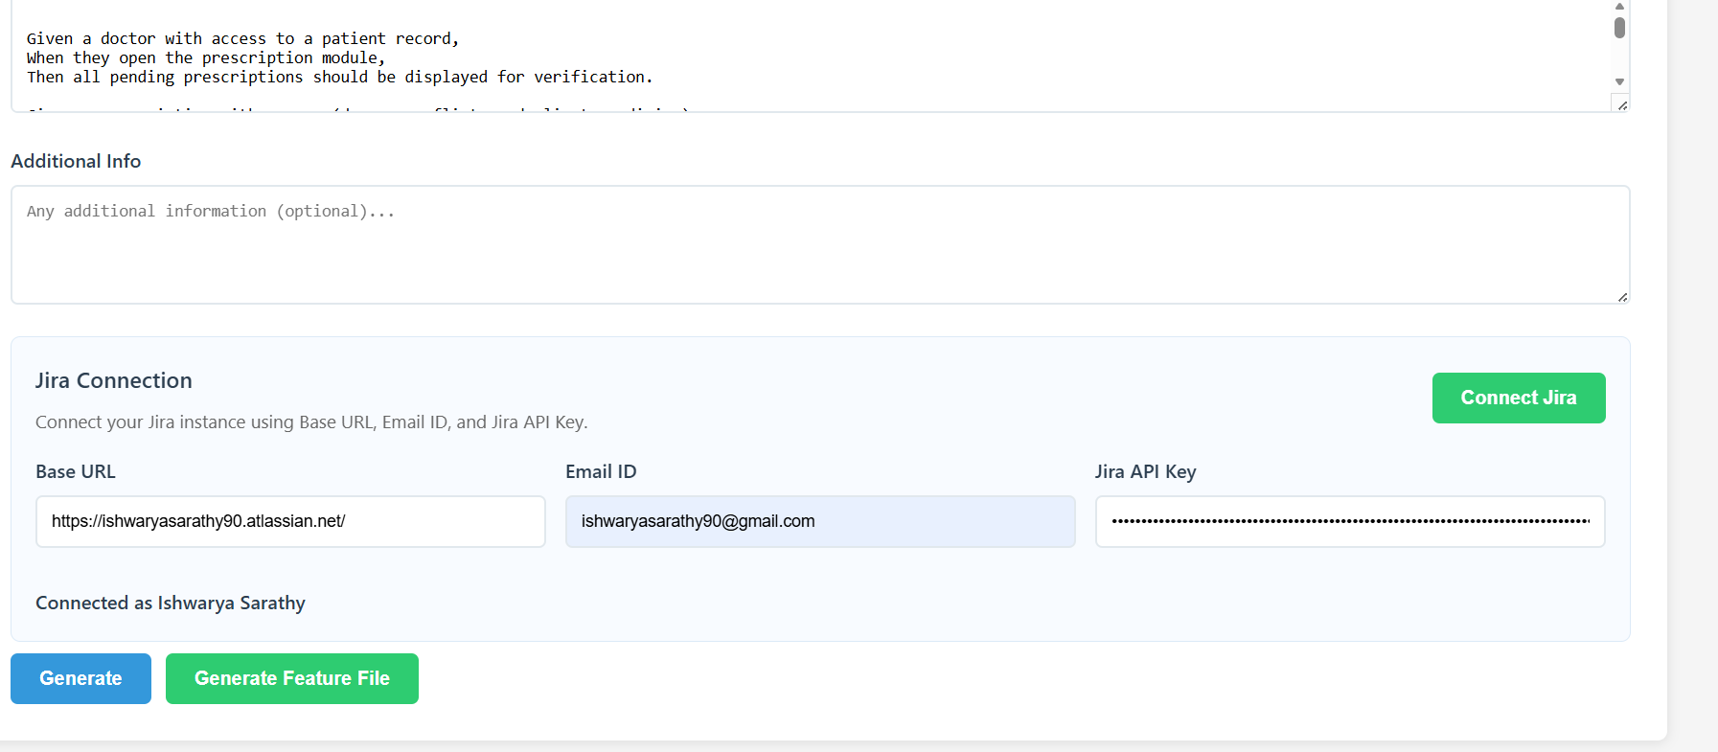

Introduced Fetch user stories button and fetch the stories
